## **Image Uploader Module Manual**

There are 2 privileges in this module. One is **Multiple Image Uploader** and another is  **Single Image Uploader**.

**Multiple Image Uploader:**

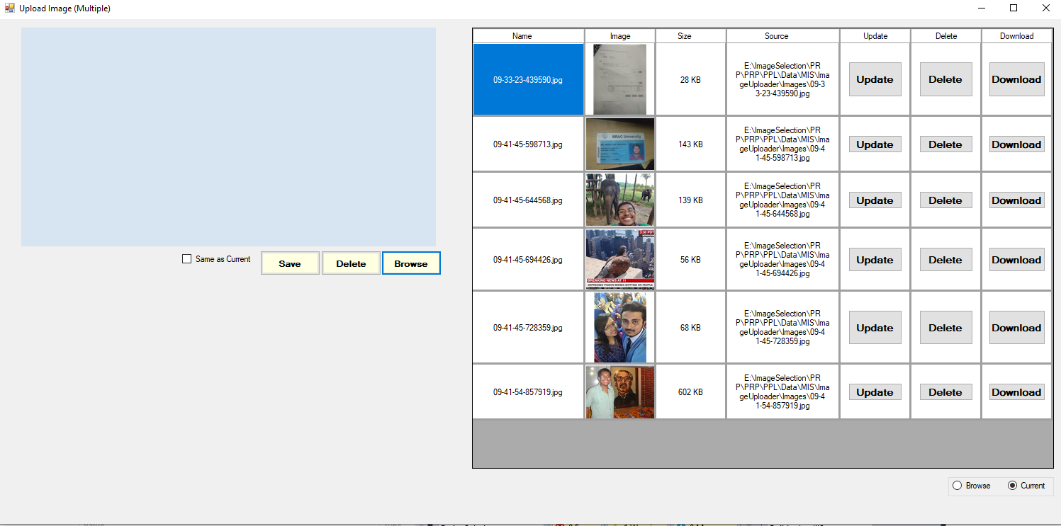

**Single Image Uploader:**

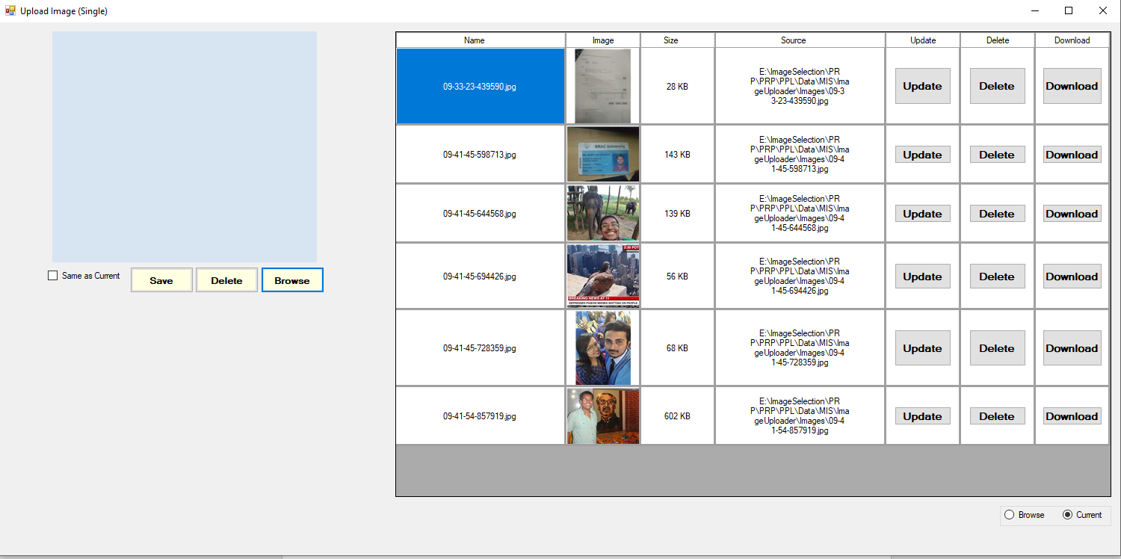

The main difference between the two form is that one can upload / save multiple image while other can do once.

**Features:**

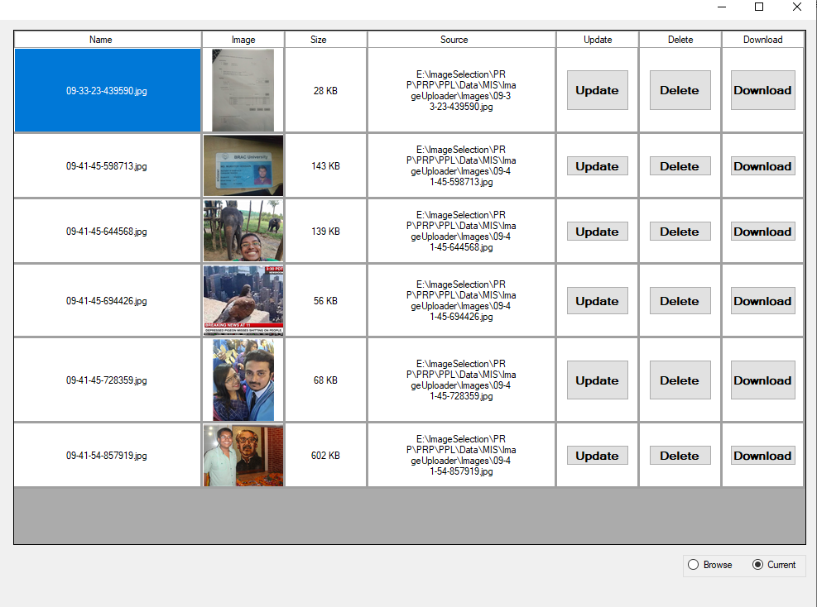

This part contains a datagrid and 2 radio button. If the radio button is selected to **Current**, it will load the images of the project file. If the radio button is selected to **Browse**, it will give user the option to choose any folder. The datagrid shows all the images of a given folder.

There are 3 buttons in every row of datagrid. They are **Update, Delete** and **Download.**

By clicking on Download button, user can save the image in his computer.

By clicking on Delete button, user can Delete the image permanently.

By clicking on Update button, user can replace the image. It will give user opportunity to choose the image he wants to save. After choosing, both of the images will show on the lower left corner like the example below.

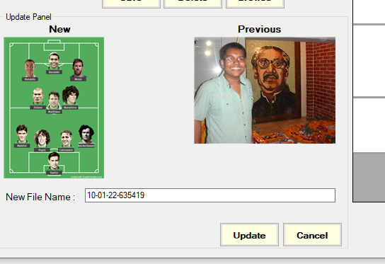

New Image will have a randomly unique generated name which user can also edit. After clicking on update, user will replace the previous image with the new one.

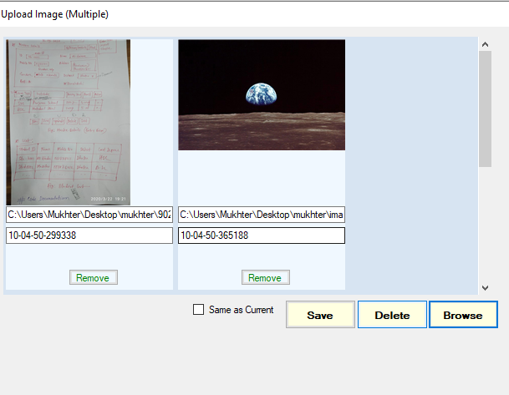

On Top Left side, we 3 buttons (**Browse, Save, Delete**) and a Blue panel. By clicking on browse, a user can choose image(s) from his computer. On **Multiple Image Uploader**, user can choose any number of pictures while on **Single Image Uploader**, he can choose one. Thus, it will remove previous images loaded on the Blue panel. By clicking on **Delete,** user can permanently delete all the images came to blue panel from his computer. By clicking on **Save,** user will save these images on the location he chooses. If **Same as Current** is selected then the images will be saved in the Current project location, otherwise it will ask for a location before saving. User can change the name of every image like it was on update. By clicking on **Remove** on the Blue Panel, user can remove the image from the panel. A removed picture from blue panel can’t be saved or deleted.